Pre-Calc Unit 3 Quiz 1

Name: ___________________ Block: __________

*Level 2: Graph and Identify Domain and Range*



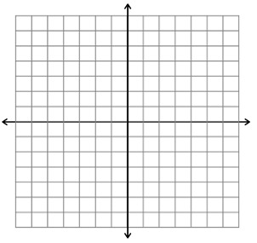

D: ______ R: ______ D: ______ R: ______   
   
3.) $f\left(x\right)={3log}_{4}\left(x-2\right)+1$ 4 $.) g\left(x\right)=ln⁡(x+4)$

D: ______ R: ______ D: ______ R: ______

*Level 3: Evaluate for x.*

5. ___________

6. ___________

7. ___________

8. ___________

*Level 4 Write and Equation and Solve the following.*

1. The equation for compound interest (A) is modeled: $A=P(1+\frac{r}{n})^{nt}$ 
   , where P is your initial deposit, r is the rate (written as a decimal), n is the number of compounds per year and t is the amount of years. If you initially depots $800 in an account that yields 6% interest and is compounded every month, how many years (rounded to 1 or 2 decimal places) will it take have $5,000 in your account assuming you make no further deposits or withdrawals.